

**cDOT 9.1Px AV Connector Upgrade**

**Authors:** Ian Daniel

**Contributors: Craig Goettig**, Joel Edstrom

**Document Version:** V0.1

**Date:** July 2017

Status: Draft

**CONFIDENTIAL INFORMATION**

This document contains information proprietary to Thomson Reuters and may not be reproduced, disclosed or used in whole or part without express permission of Thomson Reuters.

© Thomson Reuters 2017

Contents

1 Introduction 3

1.1 Management Summary 3

1.2 Change History 3

1.3 Distribution List 4

1.4 Glossary 4

2 AV Connector Upgrade 5

2.1 Description 5

2.2 Tasks 5

2.2.1 Ensure The System Meets the Software Requirements 5

2.2.2 Download the Connector 5

2.2.3 Upgrade The Connector 6

2.3 Testing 9

2.3.1 Connectivity Testing. 9

2.3.2 Virus Detection Testing. 10

2.3.3 cDOT 8.2.3P5 Test 10

2.3.4 cDOT 9.1P3 test 11

# Introduction

## Management Summary

This document details the process used to upgrade and test the AV Connector which is upgraded to 1.0.3 prior to any cDOT upgrade to 8.3.x or 9.1.x

## Change History

|  |  |  |  |
| --- | --- | --- | --- |
| **Ver** | **Date** | **Author** | **Key Changes** |
| 0.1 | July 2017 | Ian Daniel | Initial Version |
|  |  |  |  |
|  |  |  |  |
|  |  |  |  |
|  |  |  |  |
|  |  |  |  |
|  |  |  |  |
|  |  |  |  |
|  |  |  |  |
|  |  |  |  |
|  |  |  |  |
|  |  |  |  |
|  |  |  |  |
|  |  |  |  |

## Distribution List

|  |  |
| --- | --- |
| **Name** | **Role** |
| Storage Engineering | Reviewer |
| Storage Delivery | Reviewer |
| Storage Architecture | Reviewer |

## Glossary

|  |  |
| --- | --- |
| **Term** | **Definition** |
| cDOT | clustered Data ONTAP |
| Vserver | A logical storage virtual server, also known as a Storage Virtual Machine (SVM), which contains LIFs, Volumes, and configuration information such as access control details. |
| LIF | Logical Interface – a cDOT logical network interface with an IP address, assigned to a single Vserver. |
| CIFS | Short for Common Internet File System, a protocol that defines a standard for remote file access using millions of computers at a time. With CIFS, users with different platforms and computers can share files without having to install new software. |
| SMB | Short for Server Message Block, a message format used by DOS and Windows to share files, directories and devices. |
| NFS | A distributed file system protocol originally developed by Sun Microsystems in 1984, allowing a user on a client computer to access files over a computer network much like local storage is accessed. |

# AV Connector Upgrade

## Description

In order to upgrade the AV connector and test it post upgrade, we need to perform the following steps.

## Tasks

The following tasks are carried out.

### ****Ensure The System Meets the Software Requirements****

In order to upgrade the systems involved must meet these requirements (from NetApp Support Site):

System requirements

The following are the system requirements:

Antivirus Connector uses SMB 2.0 or later, which means that it must be installed on only the following Windows platforms:

Windows 2008

Windows 2008 R2

Windows 2012

Windows 2012 R2

.NET version 3.0 and later

.NET framework 3.x or 4.x

One or both of these frameworks are installed by default on all supported Windows releases, but in some cases .NET must be enabled. This can be done by using Server Manager or PowerShell®.

Data ONTAP 8.2.1 and later

Antivirus Connector communicates with only Data ONTAP 8.2.1 and later. Contact your antivirus vendor to get a version of their software that works with clustered Data ONTAP Antivirus Connector.

32-bit and 64-bit platforms are supported, and ontapavc can run in a virtual machine. However, for best performance, antivirus vendors recommend using a dedicated machine for antivirus scanning.

You must also view the NetApp Interoperability Matrix for information about the supported protocols, antivirus vendor software versions, Data ONTAP versions, and Windows servers.

### ****Download the Connector****

The connector is available here:

<http://mysupport.netapp.com/NOW/download/software/ontap_av_connector/1.0.3/#proddoc>

### ****Upgrade The Connector****

Upgrade the connector as follows:

#### Check the current installed version.

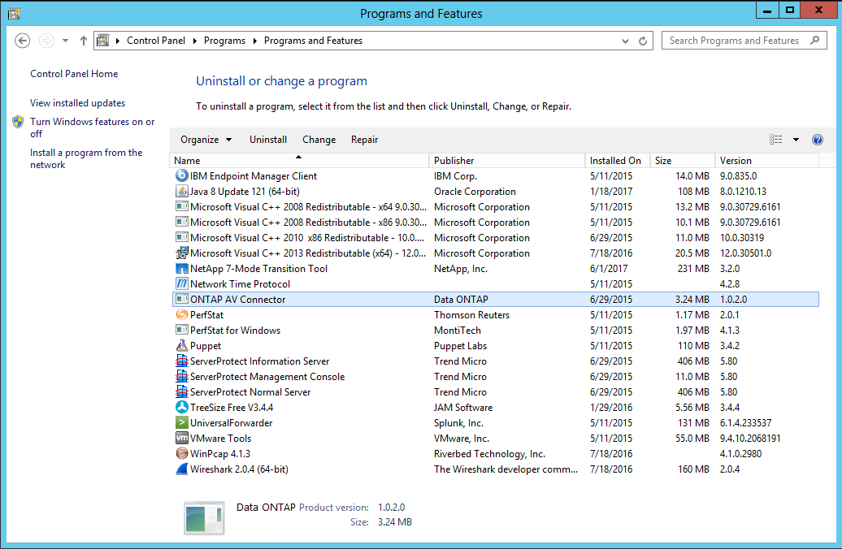

#### Run the Installer.

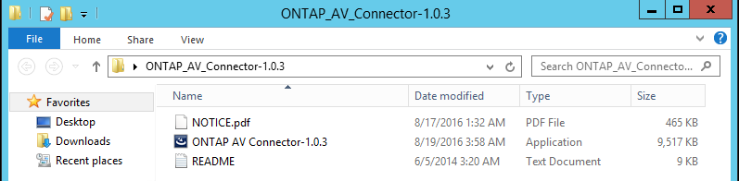

You will be prompted to confirm an upgrade. Select Yes.

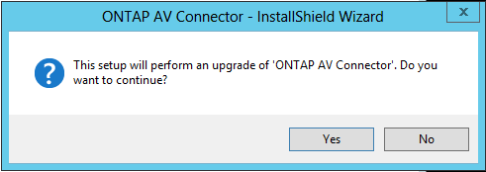

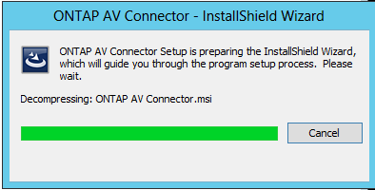

You will be prompted to continue. Select Next.

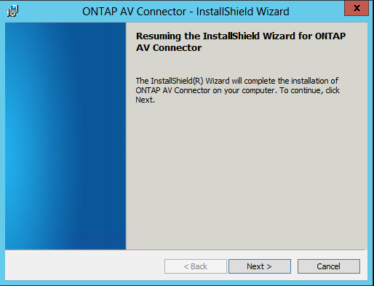

You will be prompted for your account details. Use the AV Account setup for this use: mgmt\svcavnas and press Next.

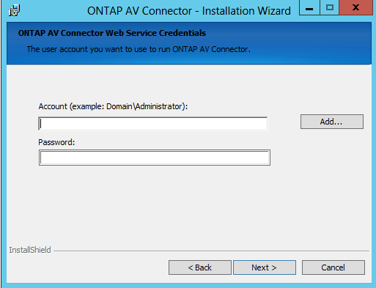

You will be asked to confirm the Upgrade, select Upgrade.

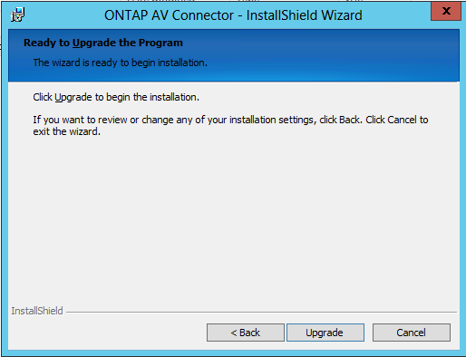

The upgrade is performed and you will see this confirmation.

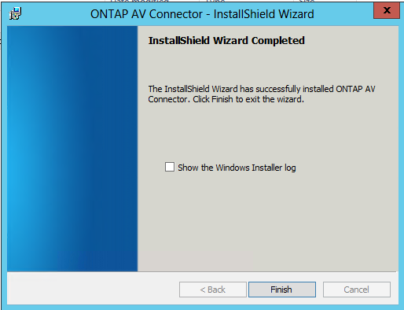

If you want to check the logfile select the check box and then select Finish.

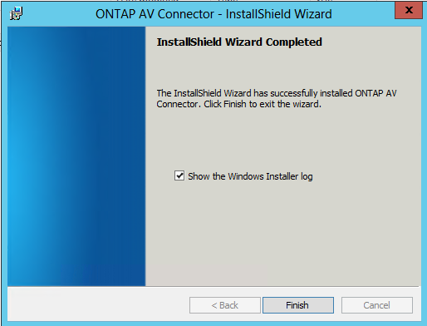

Example logfile is embedded below.



## ****Testing****

We need to test the connector connectivity and also the ability to still detect and clear viruses on all versions of ONTAP connected to it. This will be ONTAP 8.2.x and 9.1.x for the purpose of this test.

### ****Connectivity Testing.****

Open the connector icon.

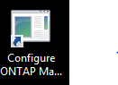

Then select a system to test.

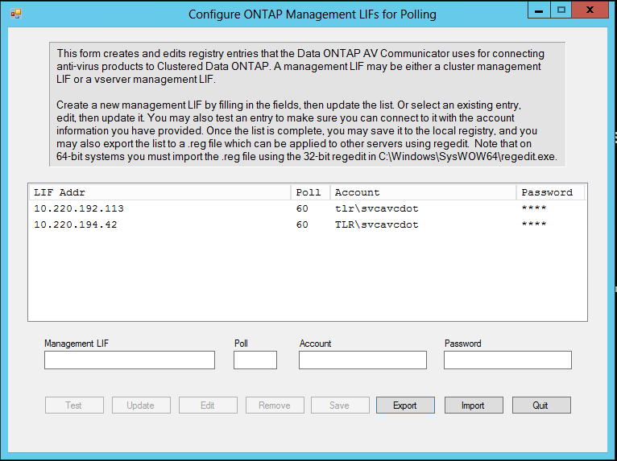

Press the Test button.

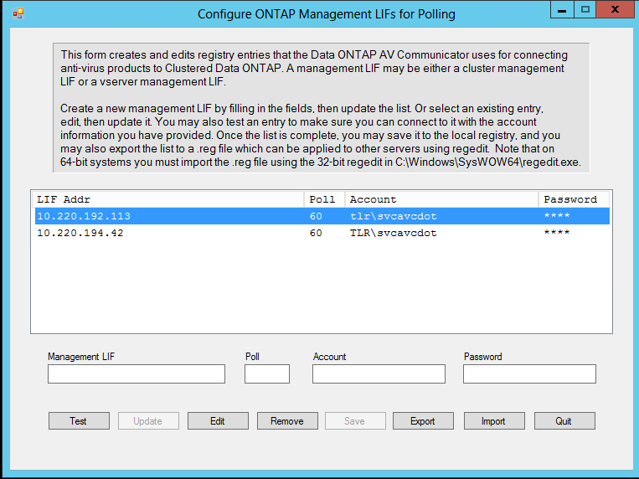

Test results are shown once completed.

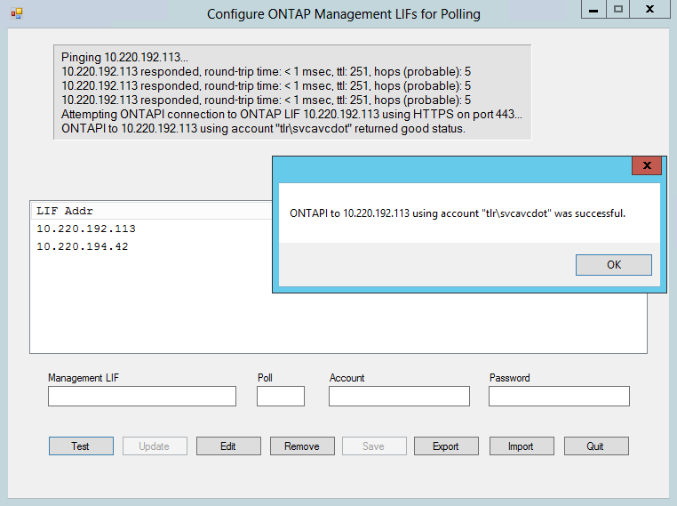

Repeat for all systems in the connector or a subset if there are a larger number than we have in the lab.

### ****Virus Detection Testing.****

For these tests, we use a test EICAR header available from here:

<https://en.wikipedia.org/wiki/EICAR_test_file>

Simply map a share from a vserver that has AV enabled and edit a test file. Copy the string into the file and save it. The virus should be detected and cleaned. You will see an event on the server in the Trend AV console and also on the cluster.

### cDOT 8.2.3P5 Test

* Create text document and insert test header.
* Save Document
* Result in cDOT logs

Not logged in event logs for cDOT 8.2.x

* Result in AV console

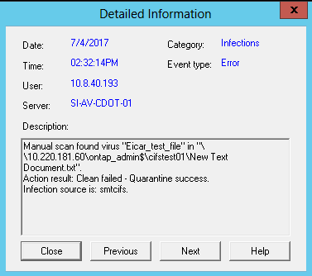

### cDOT 9.1P3 test

* Create text document and insert test header.
* Save Document
* Result in cDOT logs

7/4/2017 14:43:29 orf-lab2554-02 ERROR Nblade.vscanVirusDetected: Possible virus detected. Vserver: labsvm-e0005, vscan server IP: 10.220.177.203, file path: \cifs_test_01\New Text Document.txt, client IP: 10.8.40.193, SID: S-1-5-21-2012327785-2259879848-3711903672-181740, vscan engine status: 222200002, vscan engine result string: Virus Eicar_test_file Found!.

* Result in AV console

